By Panichaya Chomsuwan
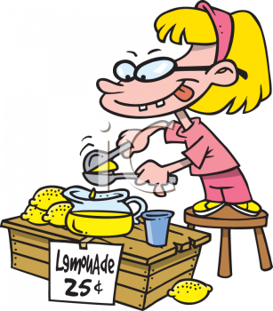
Selling is the way that you help customers to buy products and services from your business.
The selling process involves creating a relationship with customers, identifying the customer's needs and wants, providing possible solutions that meet their needs and wants and closing the sale. It may also involve ongoing management of the buyer and seller relationship
A customer – purchases and pays for a product or service
A consumer – is the ultimate user of the product or service; the consumer may not have paid for the product or service
There are a number of common selling techniques that businesses can utilise to meet the needs of their customers, including:
- Direct selling - salespeople deal directly with customers face to face.
- Retail selling - products are offered through a shop that customers can visit.
- Agency selling - an agent sells products and services on behalf of the supplier.
- Telesales - products and services are sold directly on the telephone without face to face contact.
- Door to door selling - salespeople visit potential customers in their homes and sell to them directly.
- Business to business selling - businesses sell directly to other businesses.
- Business to government selling - businesses develop solutions and sell to government agencies and departments.
- Mail order selling - customers buy directly from a catalogue without seeing the product firsthand.
- Online Selling - products and services are sold directly on the internet.
Advertising presents or promotes the product to the target audience through a variety of media such as TV, radio, cinema, online and magazines to encourage them to buy.

Personal Selling Process

1. Pre-sale preparation: The first step in personal selling is the selection, training and motivation of salespersons

2. Prospecting : It refers to locating or searching out prospective buyers who have the need for the product and the ability to buy it. Potential customers may be spotted through observation, enquiry and analysis of records of existing customers

3. Approaching : Before calling on the prospects, the salesperson should fully learn their number, needs, habits, spending capacity, motives, etc. Such knowledge helps in selecting the right sales appeal. After such learning, the salesperson should approach the customer in a polite and dignified way. He should introduce himself and his product to the customer. He should greet the customer with a smile and make him feel at home. He should introduce himself and his product to the customer

4. Presentation : For this purpose, the salesperson has to present the product and describe its features in brief.

5. Handling objections: A sale cannot be achieved simply by creating interest and desire. Every customer wants to make the best bargain for the money he is spending Presentation and demonstration of the product are likely to create doubts and questions in his mind. The salesman should clear all doubts and objections without entering into a controversy and without losing his temper

6. Closing the sale: This is the climax or critical point in the personal selling process. Completing the sale seems to be an easy task but inappropriate handling of the customer can result in loss of sale. The salesman should not force the deal but let the customer feel that he has made the final decision

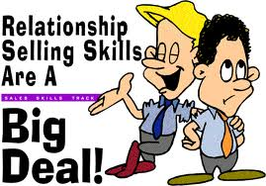
7. Follow-up : It refers to the activities undertaken to ensure that the customer is satisfied with the article and the firm. These activities include installation of the products, checking and ensuring its smooth performance, maintenance and after-sale service. It helps to secure repeat sales identify additional prospects and to evaluate salesman's effectiveness.

AIDA Model
AIDA stands for attention, interest, desire, and action
- The "A" represents attention or awareness, and the ability to attract the attention of the consumers.
- The "I" is interest and points to the ability to raise the interest of consumers by focusing on and demonstrating advantages and benefits (instead of focusing on features, as in traditional advertising).
- The "D" represents desire. The advertisement convinces consumers that they want and desire the product or service because it will satisfy their needs.
- The "A" is action, which leads consumers toward taking action by purchasing the product or service.

Marketing mix
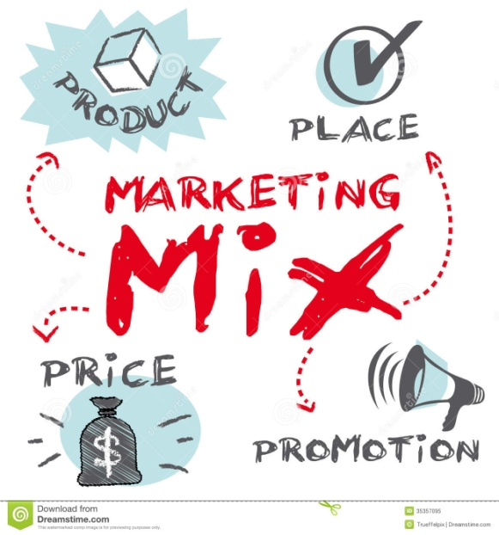
"Marketing mix" is a general phrase used to describe the different kinds of choices organizations have to make in the whole process of bringing a product or service to market.
The 4Ps are:
- Product (or Service).
- Price.
- Place.
- Promotion.
Promotion mix
1. Advertising is a form of non personal promotion. It is when companies pay to promote ideas, goods, or services in a variety of media outlets. It can be found everywhere. With advertising, a company engages in a one-way communication to the prospect or customer. Examples: magazines, newspapers, television, websites, city buses, etc.
2. Public relations activities enable an organization to influence a target audience. Most of the time, public relation campaigns try to create a favorable image for a company, its products, or its policies. Companies give news releases to announce newsworthy developments about a company's products or services, distribution channels, facilities, operations, partners, revenues and earnings, employees, and events. Publicity is one tactic that public relations professionals use. This means bringing newsworthy information to the public.
Examples: a campaign to encourage businesses to donate computers to schools, donating to hospitals, donating to a cause
3. Personal selling is one-to-one communication between seller and prospective purchaser. It generates direct contact with prospects and customers. It is one of the most expensive forms of promotion. Examples: personal meetings, telemarketing, e-mails, and correspondence
4. Sales promotion basically represents all marketing activities other than personal selling, advertising, and public relations. Sales promotions are used to stimulate purchasing and sales and the objectives are to increase sales, inform potential customers about new products, and create a positive business or corporate image. Examples: coupons, product samples, point-of-purchase displays
.
Product Life Cycle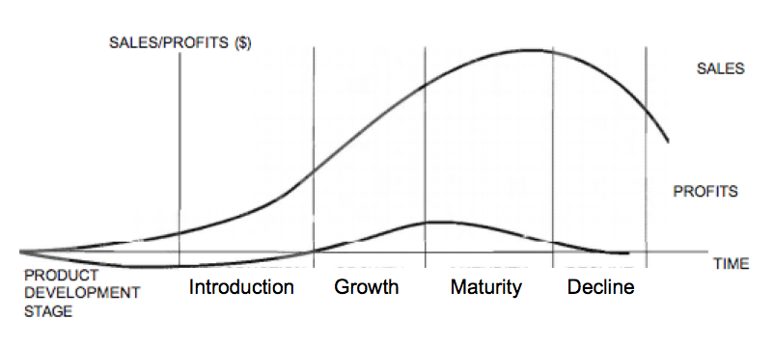
A Product life cycle shows the different stages through which a product goes from development to decline.
1.Introduction Stage
- Product launched into the market.
- Sales grow slowly.
- Informative advertising is done.
- Firm might not earn a profit at this stage.
- Price skimming may be used if the product is new invention and has no competitors.
- Competitive pricing may be used if it already has lot of competitors.

2. Growth Stage
- Sales grow rapidly.
- Persuasive advertising may be used.
- Prices may be reduced if faced by stiff competition.
- Firm starts earning profits.

3. Maturity Stage
- Sales increase slowly and reach the highest sales figures.
- Competition is at the maximum level as many new ‘me too’ products may be in the market.
- Promotional pricing might be a good option.
- Profits are at the highest level as the firm is also getting economies of scale.
- Repetitive advertising is done to remind the consumers.

4. Saturation Stage
- Sales are stagnant.
- Maximum competition but no new competitors and the market is already crowded with the same types of products.
- Promotional pricing or competitive pricing may be a good choice.
- Advertising efforts at its highest point.

5. Decline Stage
- Sales start to decline.
- Profits start to come down.
- Marketing research it done to find out whether this decline is permanent or temporary. If the decline is permanent in nature then stop the production of the product, otherwise implement extension strategies.
- Advertising is reduced.

6. Extension stage
- Introduce new variations of the original product
- Try to sell the product in different markets.
- Make small changes in the colour, design or packaging
- Start a new advertising campaign.
- Add more retail outlets to boost sales.

